**DIGITAL MARKETING**

**PROJECT**

**CREATING A CONTENT MARKETING PLAN BASED ON HUBSPOT**

**Step 1:**

1. Place the logo and Write the company name.
2. Write the objectives and the author of document



**Step 2:**

1) Write the table of contents

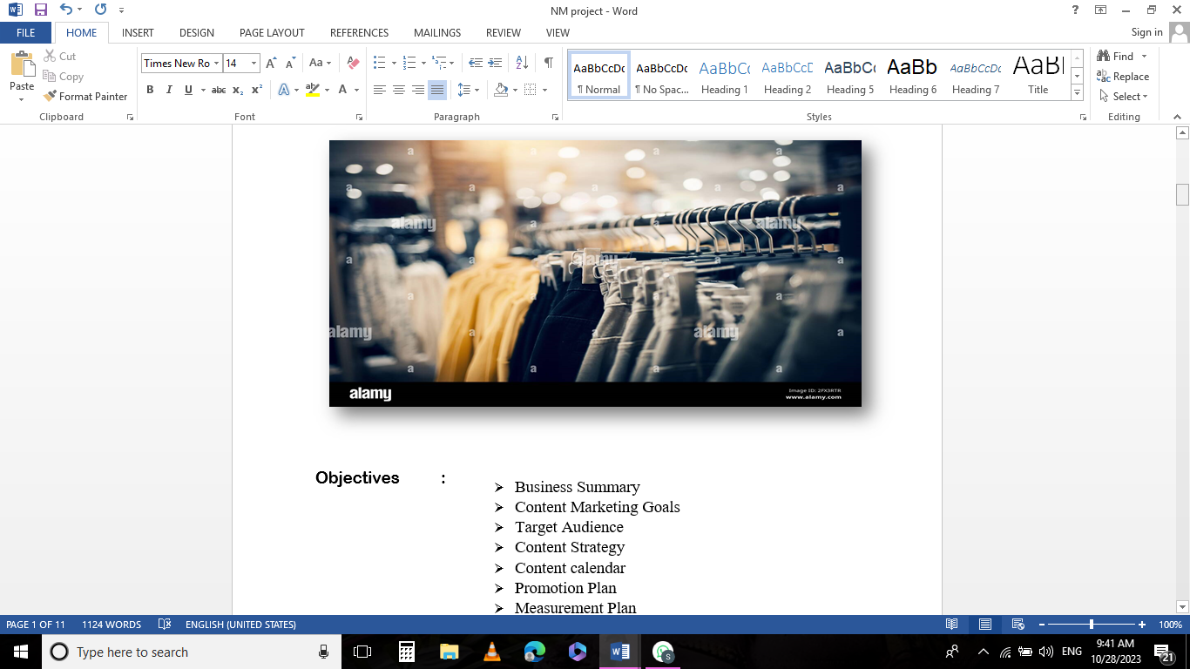

**Step 3:**

BUSINESS SUMMARY

1) Company name

2) Mission statement

3) Products for services

4) Business Goals

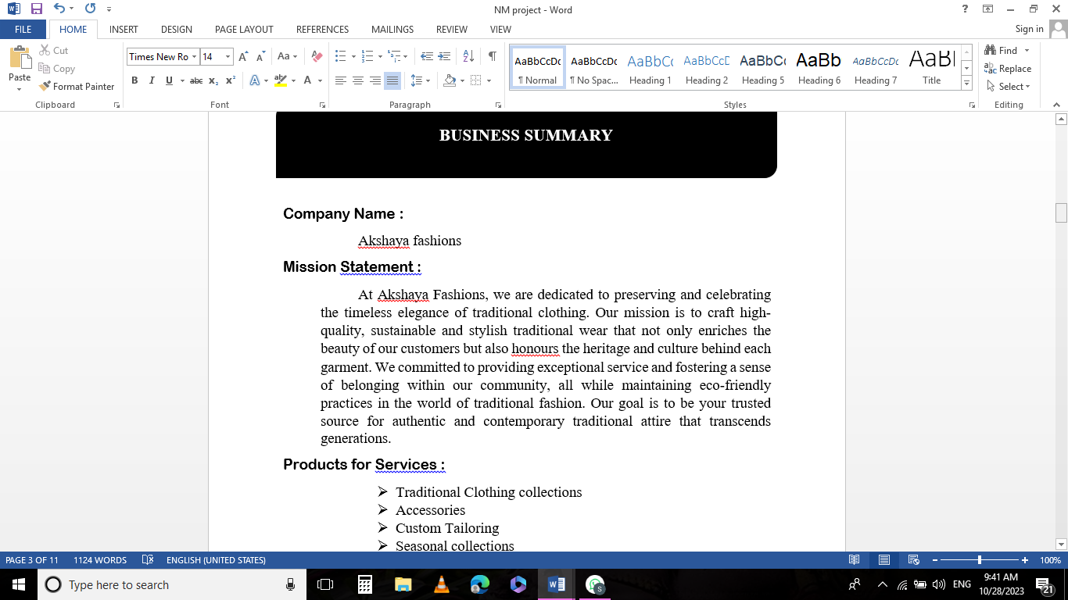**Step 4:**

CONTENT MARKETING GOALS

1) Increase brand awareness

2) Generate leads

3) Drive traffic to website

4) Boost sales and improve customer management

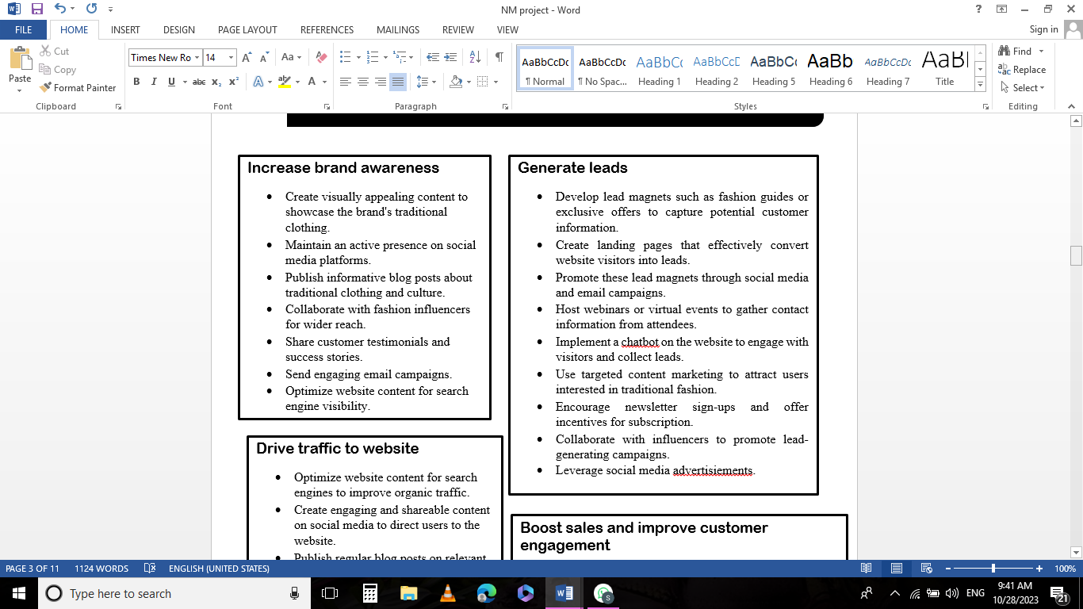

**Step 5:**

Creating content calendar

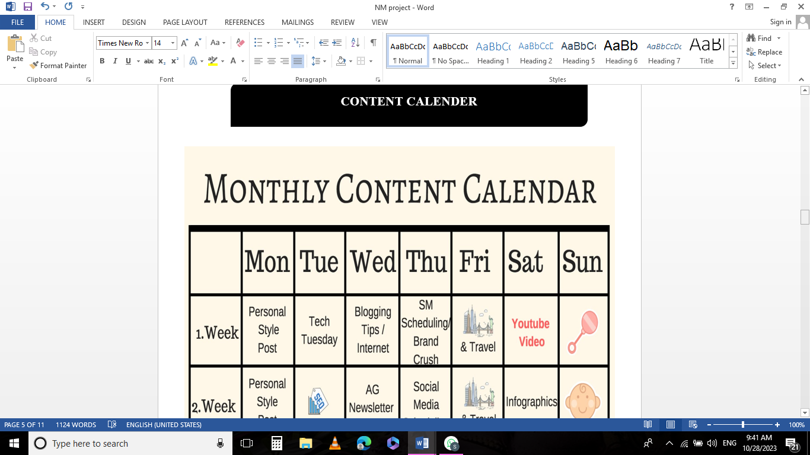**Step 6:**

PROMOTION PLAN

1) Our marketing channels

2) Marketing strategy

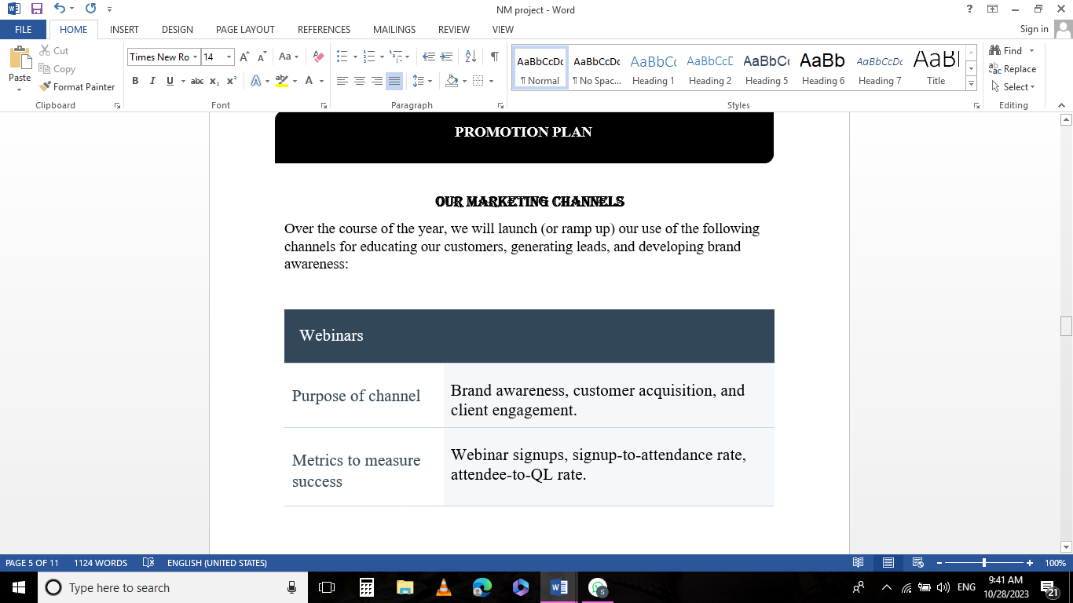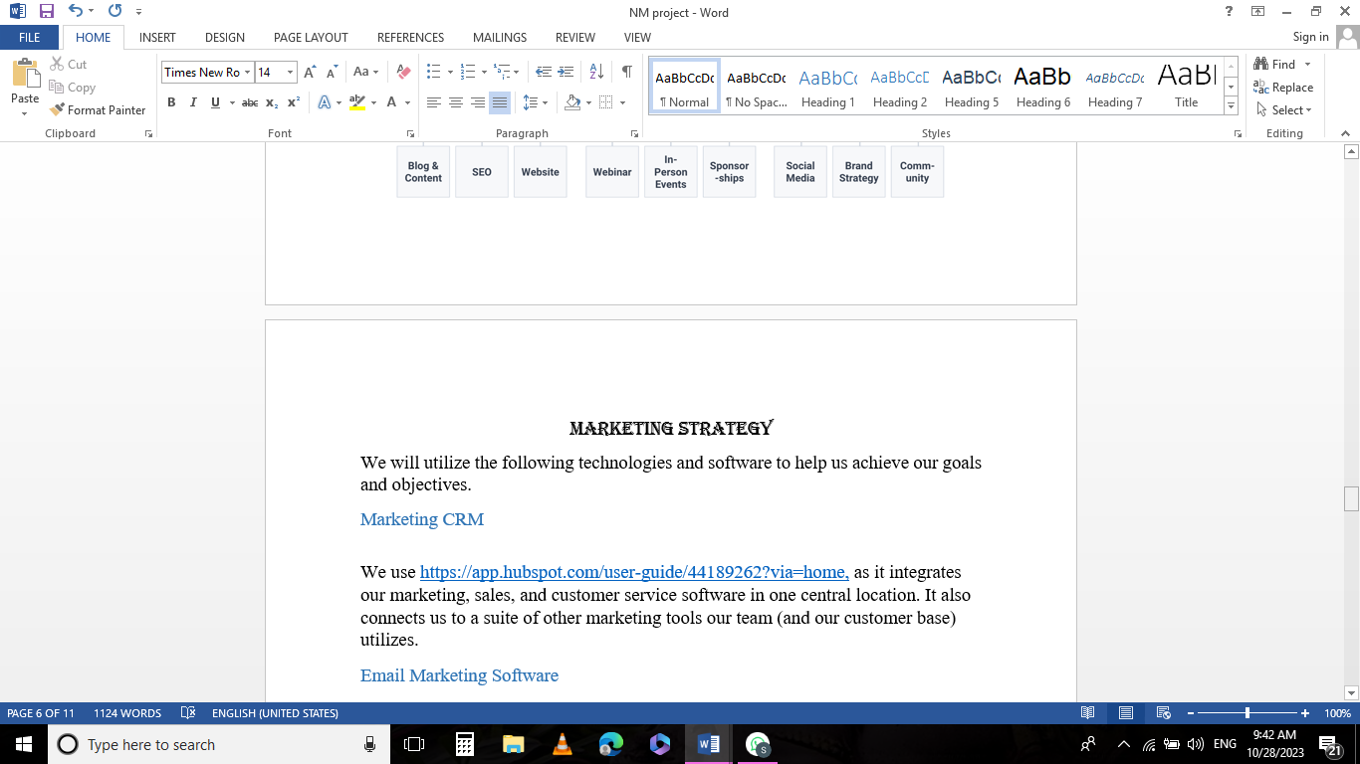

**Step 7:**

MEASUREMENT PLAN

Includes goals and Key performances.

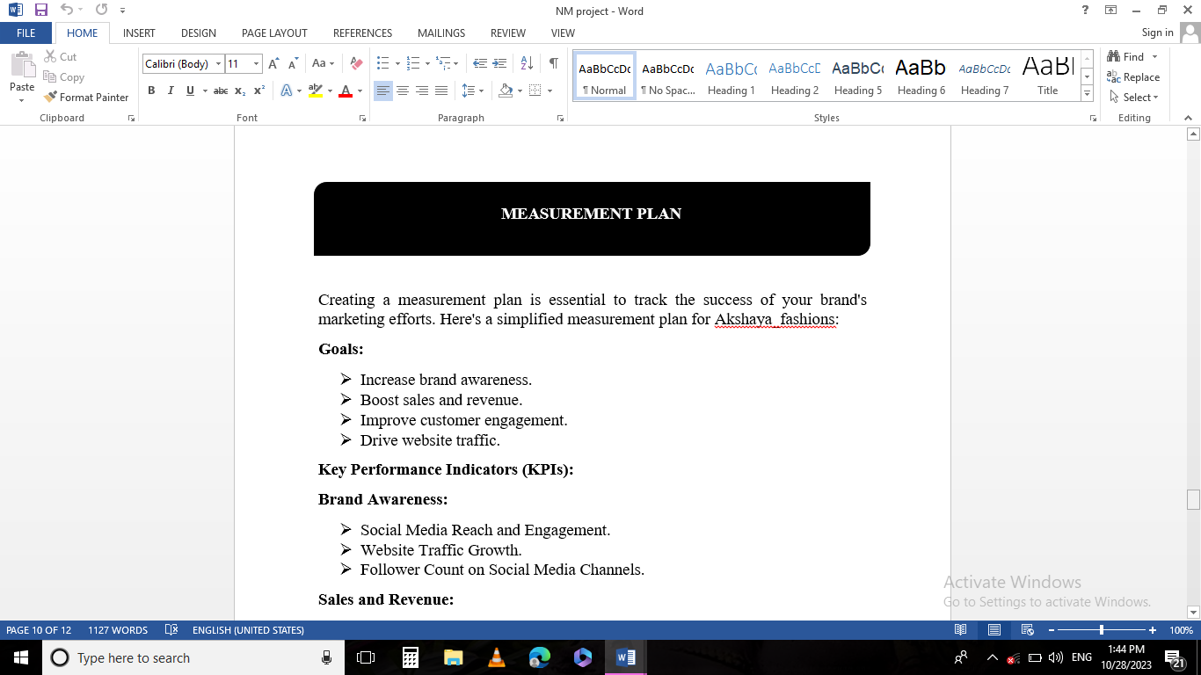

**Step 8:**

BUDGET

